project report template

1. INTRODUCTION

1.1 Overview

1.2 Purpose

2. PROBLEM DEFINITION & DESIGN THINKING

2.1 Empathy Map

2.2 Ideation & Brainstorming Map

3. RESULT

3.1 Data Model

3.2 Activity & Screenshot

4. TRAILHEAD PROFILE PUBLIC URL

5. ADVANTAGES & DISADVANTAGE

6. APPLICATIONS

7. CONCLUSION

8. FUTURES

***1. INTRODUCTION***

***1.1 Overview***

The air transportation network is a complex network which has the properties of small-world networks and scale free networks. The degree distribution of the nodes displays a heavy-tailed distribution. The hubs of the network have large connectivities and long distance connectivities some time.

***1.2 Purpose***

The air transport network is a key infrastructure asset. It is the only worldwide passenger and cargo transportation network, providing an essential link between individual countries and the winder global economy. Air services create significant value for passenger and freight users.

***2. PROBLEM DEFINITION & DESIGN THINKING***

***2.1 Empathy map***

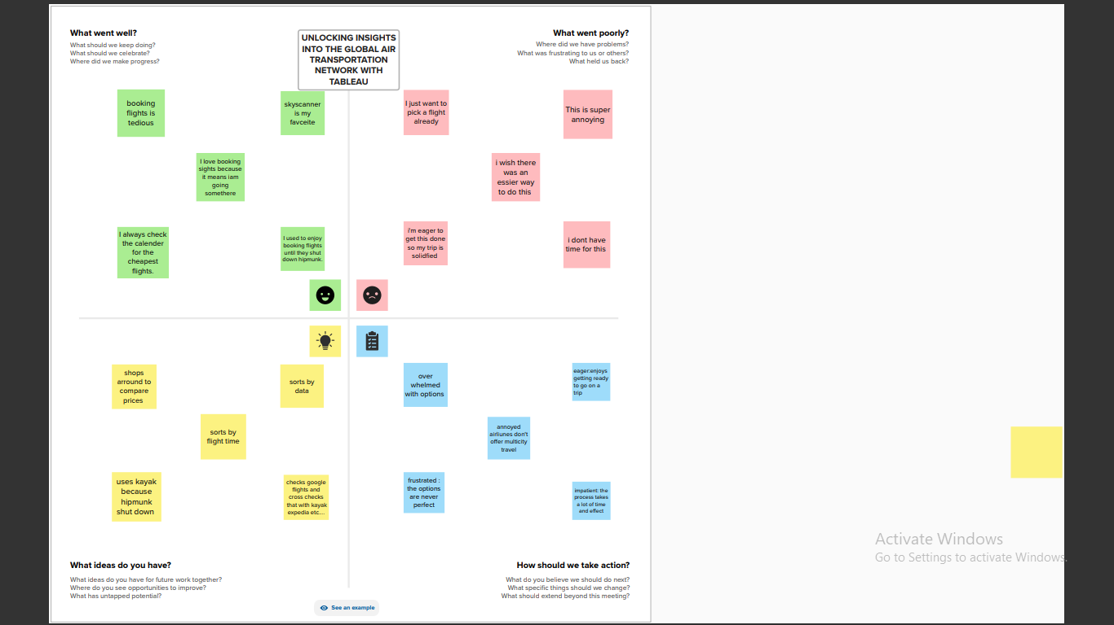

***2.2 Ideation & brainstorming map***

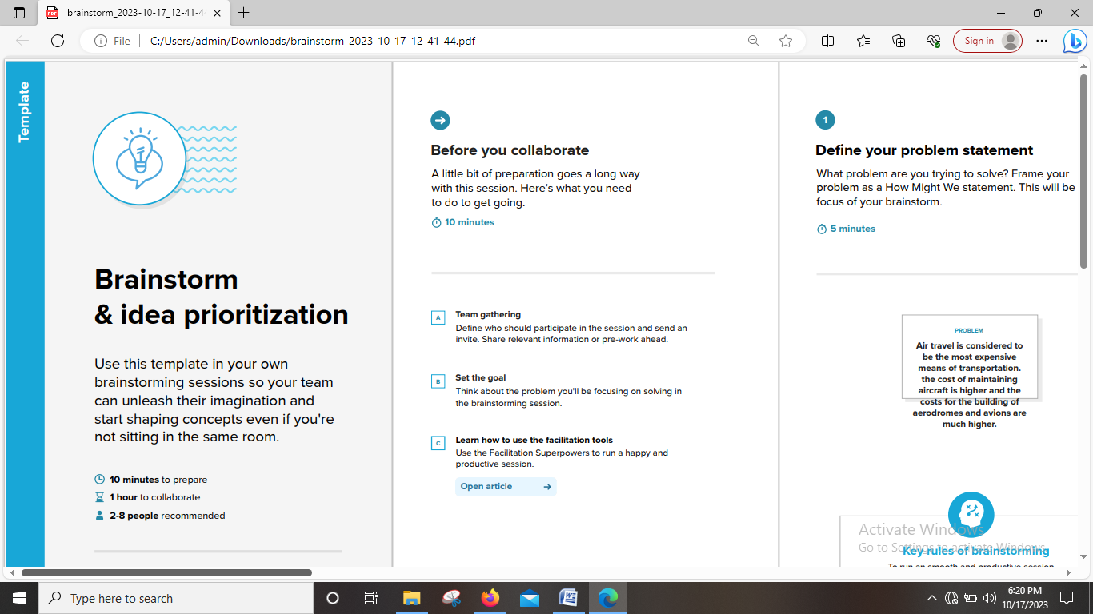

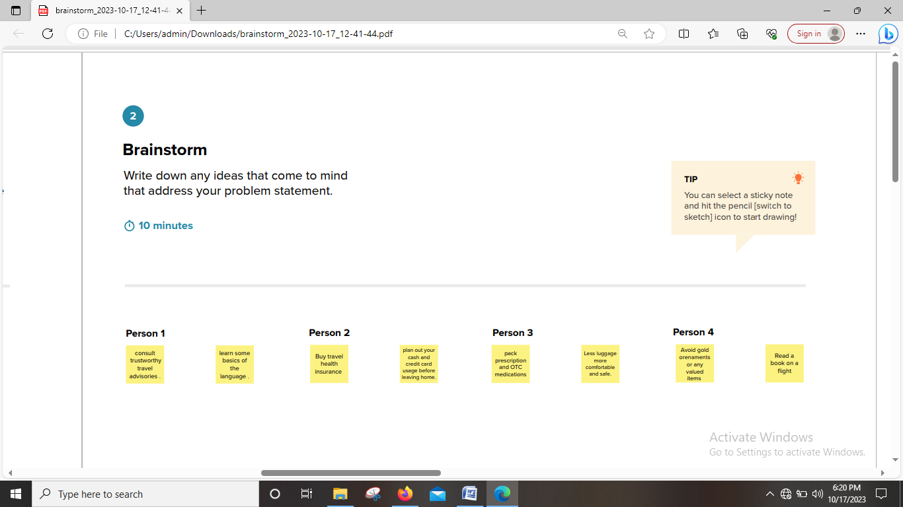

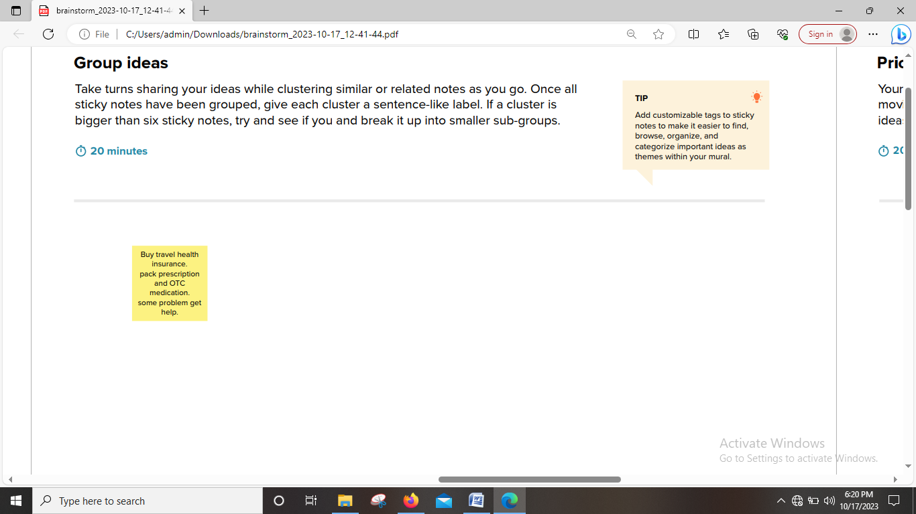

***3. RESULT***

***3.1 Data Model***

|  |  |
| --- | --- |
| Object Name | Fields In The Object |
| * Airports | Text |
| * Airlines | Text |
| * Airplanes | Text |
| * Routes | Text |

***3.2 Activity & Screenshot***

***Milestone: 1***

***Activity 1: Specify the Business Problem***

How can we improve air transport and growth of air transportation.

***Activity 2: Business Requirements***

Leverages Visual Analytics to Empower People and Organizations in Making the Most Of Their Data.

***Activity 3: Literature Survey***

Global air transportation network involves reviewing academic articles, books and other sources related to the aviation industry including statistical, economical, financial models.

***Activity 4: Social or Business Impact***

Air transport provides significant economic and social benefits. It facilitates tourism, trade, provides a lifeline for remote communities and enables a rapid response when disasters occur.

***Milestone 2: Data Collection & Extraction From***

Data collection is the process of gathering and measuring information on variables of interest, in an established systematic fashion that enables one to answer stated research question, test hypotheses, and evaluate outcomes and generate insights from the data.

***Activity 1: Collect the dataset***

https://drive.google.com/drive/folders/1RJnbcGxvIVulM3fkZH1Wz3_IbLDP2RjY?u sp=share_link

Use the link to download the dataset.

***Activity 1.1: Understand the data***

Data contains all the meta information regarding the columns described in the CSV files. We have provided a csv file.

***Column Description for airports.csv:***

***Name***: The name of the airport. (String)

***City***: The city the airport is located in. (String)

***Country:*** The country the airport is located in. (String)

***IATA***: The International Air Transport Association code for the airport. (String)

***ICAO***: The International Civil Aviation Organization code for the airport. (String)

***Latitude:*** The latitude of the airport. (Float)

***Longitude:*** The longitude of the airport. (Float)

***Altitude:*** The altitude of the airport. (Float)

***Timezone***: The timezone of the airport. (String)

***DST:*** The Daylight Savings Time of the airport. (String)

***Tz database time zone***: The timezone of the airport in the Tz database. (String)

***Type***: The type of airport (large_airport, medium_airport etc.). (String)

***Source:*** The source of the data. (String)

***Column Description for airplanes.csv:***

***Name***: The name of the airport. (String)

***IATA code***: International Air Transport Association code, a three-letter code used to identify airports. (String)

***ICAO code***: International Civil Aviation Organization code, a four-letter code used to identify airports. (String)

***Column Description for airlines.csv:***

***Name:*** The name of the airport. (String)

***IATA:*** The International Air Transport Association code for the airport. (String)

***ICAO:*** The International Civil Aviation Organization code for the airport. (String)

***Country:*** The country the airport is located in. (String)

***Alias:*** An alternate name for the airport. (String)

***Callsign:*** The call sign of the airline operating at the airport. (String)

***Active:*** An alternate name for the airport. (String)

***Column Description for routes.csv:***

***Airline***: The name of the airline operating the route. (String)

***Source airport:*** The IATA code of the airport from which the route originates. (String)

***Destination airport:*** The IATA code of the airport to which the route is headed. (String)

***Codeshare*** : Indicates whether the route is operated by another airline under a codeshare agreement. (Boolean)

***Stops:*** The number of stops on the route. (Integer)

***Equipment:*** The type of aircraft used on the route. (String)

***Activity 2: Connect dataset State & County with Tableau***

Open a tableau

Add a dataset file in the text option and data set will be connected.

***Milestone 3: Data preparation***

***Activity 1: prepare the data for visualization***

Here the dataset is available and the visualization are showed in the activity.

***Milestone 4: Data Visualization***

Data visualization is the process of creating graphical representations of data in order to help people understand and explore the information. The goal of data visualization is to make complex data sets more accessible, intuitive, and easier to interpret. By using visual elements such as charts, graphs, and maps, data visualizations can help people quickly identify patterns, trends, and outliers in the data. ***Activity 1:*** ***No of Unique Visualizations***

The number of unique visualizations that can be created with a given dataset . Some common types of visualizations that can be used to analyze the performance and efficiency of a project include bar charts, line charts, heat maps, scatter plots, pie charts, Maps etc. These visualizations can be used to compare performance, track changes over time, show distribution, and relationships between variables.

***Activity 1.1: World map showing details of all Airports within a Country***

1. Select the country airports in filter

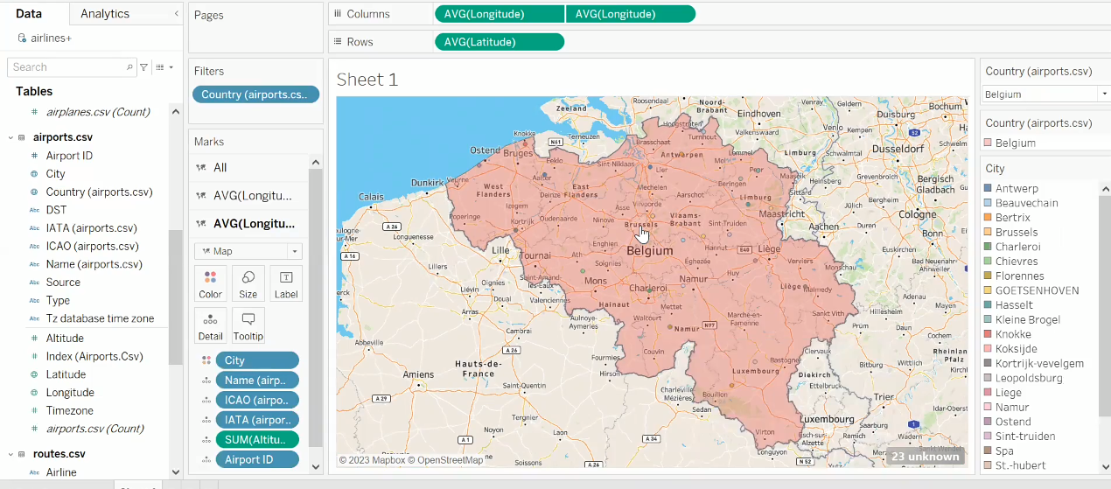

2. Columns data:

* AVG(Longitude)
* AVG(Longitude)

3. Row data:

* AVG(Latitude)

***Activity 1.2: Number of Airports within the country***

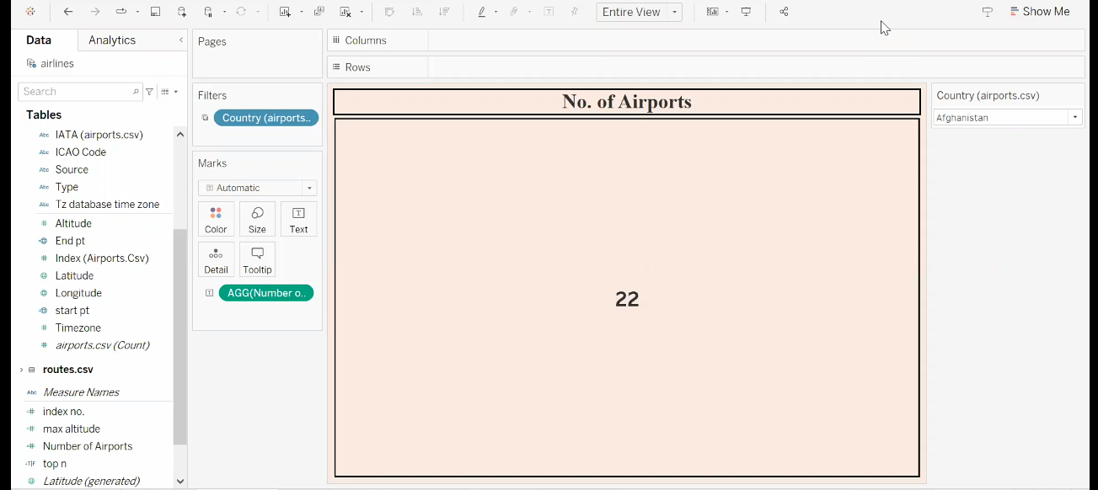

1. Filter in country airports
2. Text in AGG(number….)

***Activity 1.3: Airports at Higher altitude within a country***

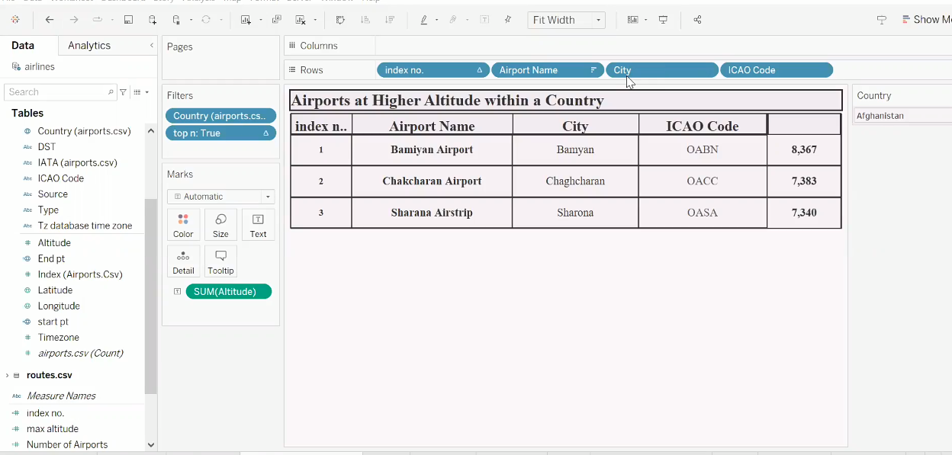

1. Filter in country airports & ton n: true
2. Text in sum(altitude)
3. Row data :
4. Index no. c. Airport Name
5. City d. ICAO Code

***Activity 1.4: Airports at Higher altitude in the world***

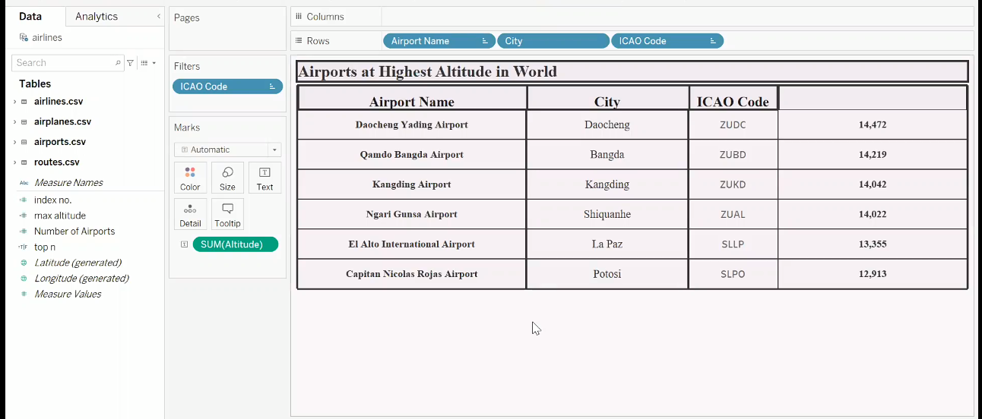

1. Filter in ICAO code
2. Text in sum(altitude)
3. Row data: 1 . Airport Name 2. City 3. ICAO Code

***Activity 1.5: Airlines within a Country***

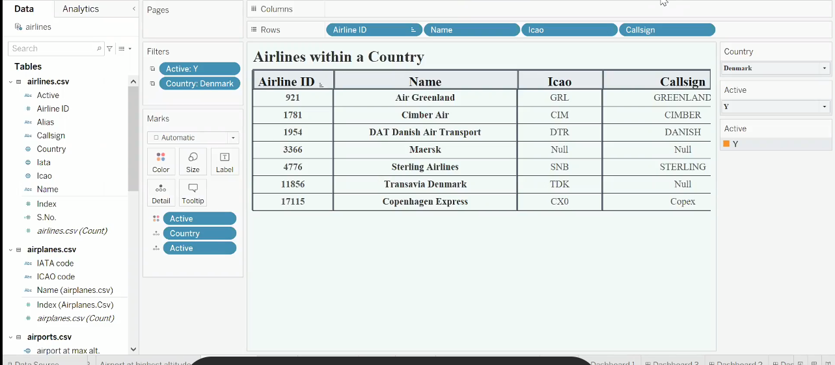

1. Filter in active:y

***Activity 1.6: Number of flights from airport***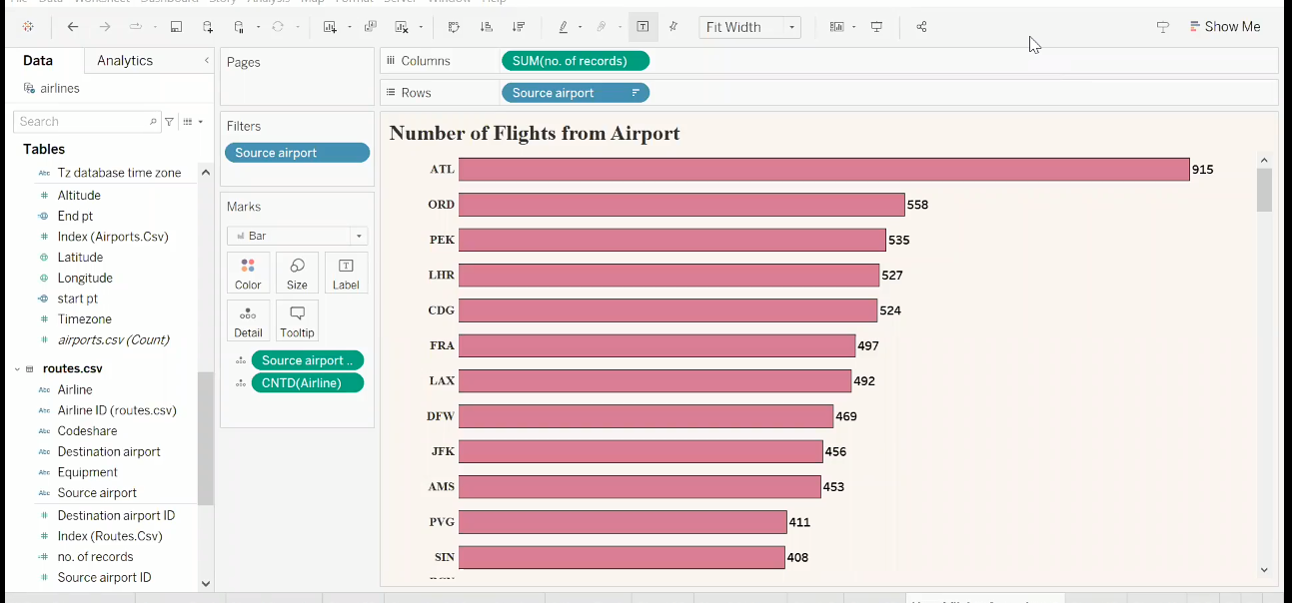

***Milestone 5: Dashboard***

A dashboard is a graphical user interface (GUI) that displays information and data in an organized, easy-to-read format. Dashboards are often used to provide realtime monitoring and analysis of data, and are typically designed for a specific purpose or use case. Dashboards can be used in a variety of settings, such as business, finance, manufacturing, healthcare, and many other industries. They can be used to track key performance indicators (KPIs), monitor performance metrics, and display data in the form of charts, graphs, and tables.

***Activity :1- Responsive and Design of Dashboard***

The responsiveness and design of a dashboard for Data-Driven insights on U.S Business Formation Statistics is crucial to ensure that the information is easily understandable and actionable. Key considerations for designing a responsive and effective dashboard include user-centered design, clear and concise information, interactivity, data-driven approach, accessibility, customization, and security. The goal is to create a dashboard that is user-friendly, interactive, and data-driven, providing actionable insights

Dashboard 1:

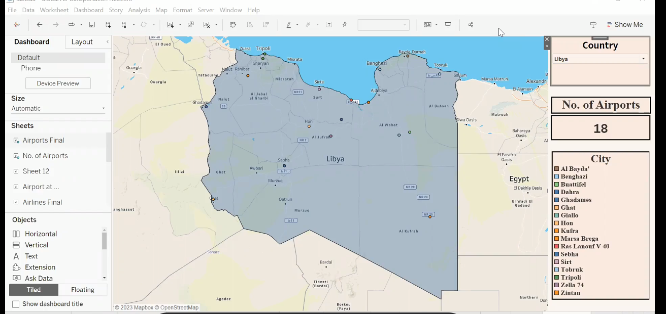

Dashboard link 1

Team leader:<https://public.tableau.com/views/kanmaniproject/Dashboard1?:language=en-US&:display_count=n&:origin=viz_share_link>

Member1:<https://public.tableau.com/views/dashboard1_16960573991930/Dashboard1?:language=en-US&publish=yes&:display_count=n&:origin=viz_share_link>

Member2:<https://public.tableau.com/views/unlockinginsightsintotheglobalairtranspotationnetworkwithtableau/Dashboard1?:language=en-US&publish=yes&:display_count=n&:origin=viz_share_link>

Member3:<https://public.tableau.com/app/profile/mani.priya/viz/book1one/Dashboard1?publish=yes>

|  |  |
| --- | --- |
|  | ReplyForward |

Dashboard2:

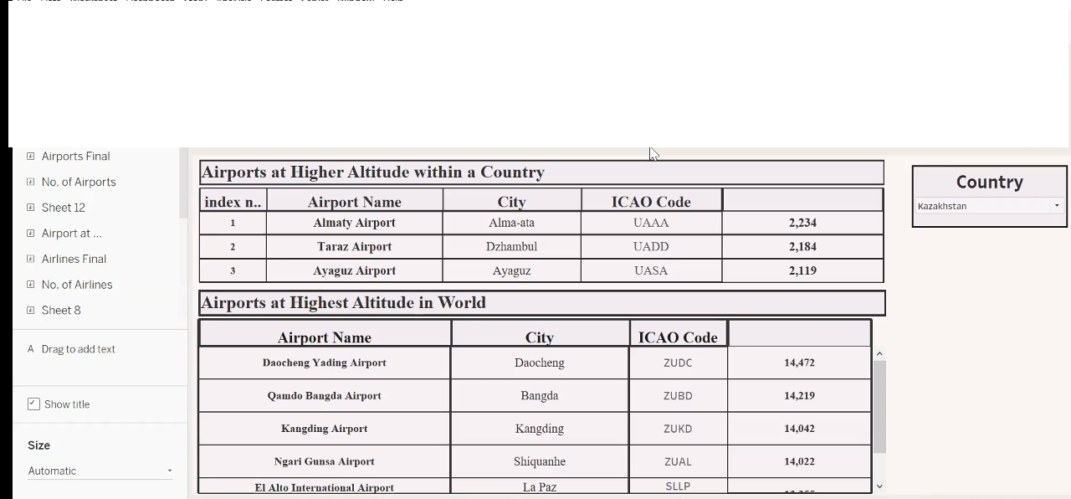

Dashboard link 2:

Team leader: <https://public.tableau.com/views/kanmaniproject/Dashboard2?:language=en-US&:display_count=n&:origin=viz_share_link>

Member1:<https://public.tableau.com/views/dashboard2_16960575676240/Dashboard2?:language=en-US&publish=yes&:display_count=n&:origin=viz_share_link>

Member2:<https://public.tableau.com/views/unlockinginsightsintotheglobalairtranspotationnetworkwithtableau/Dashboard2?:language=enUS&publish=yes&:display_count=n&:origin=viz_share_link>

Member3: <https://public.tableau.com/app/profile/mani.priya/viz/book1one/Dashboard2?publish=yes>

Dashboard3:

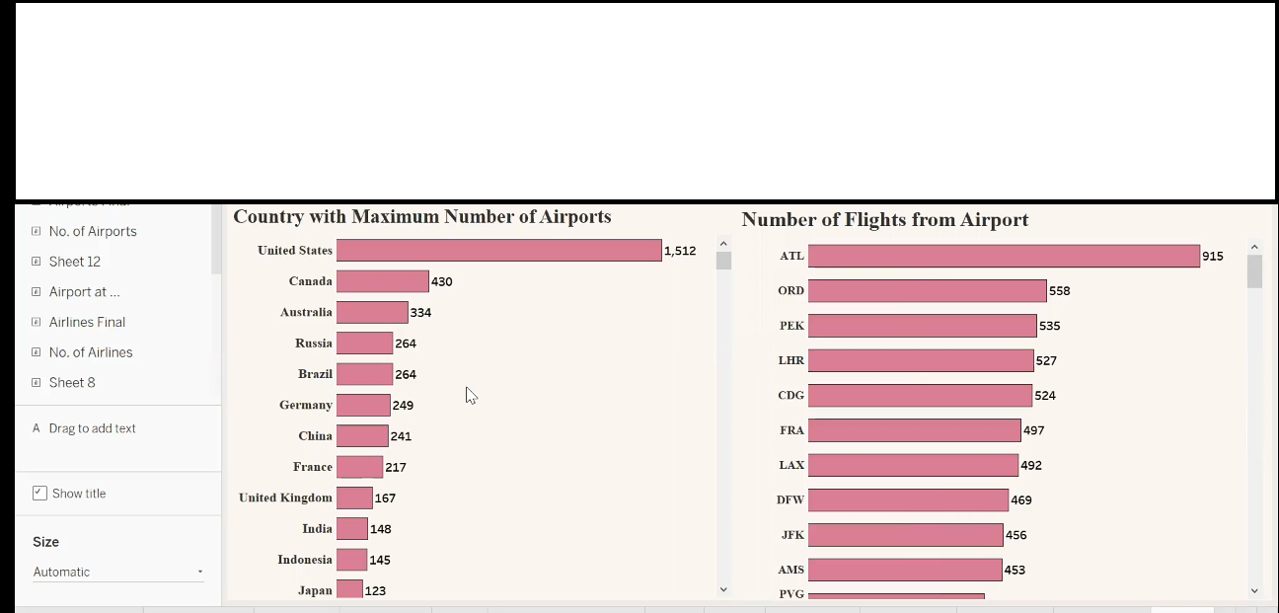

Dashboard link 3:

Team leader: <https://public.tableau.com/views/kanmaniproject/Dashboard3?:language=en-US&:display_count=n&:origin=viz_share_link>

Member1: <https://public.tableau.com/views/dashboard3_16960576782040/Dashboard3?:language=en-US&publish=yes&:display_count=n&:origin=viz_share_link>

Member2:<https://public.tableau.com/views/unlockinginsightsintotheglobalairtranspotationnetworkwithtableau/Dashboard3?:language=en-US&publish=yes&:display_count=n&:origin=viz_share_link>

Member3:<https://public.tableau.com/app/profile/mani.priya/viz/AIRLINES_16963024665660/Dashboard3?publish=yes>

Dashboard4:



Dashboard link 4:

Team leader:<https://public.tableau.com/views/kanmaniproject/Dashboard4?:language=en-US&:display_count=n&:origin=viz_share_link>

Member1: <https://public.tableau.com/views/dashboard4_16960577837930/Dashboard4?:language=en-US&publish=yes&:display_count=n&:origin=viz_share_link>

Member2:<https://public.tableau.com/views/unlockinginsightsintotheglobalairtranspotationnetworkwithtableau/Dashboard4?:language=en-US&publish=yes&:display_count=n&:origin=viz_share_link>

Member3:<https://public.tableau.com/app/profile/mani.priya/viz/AIRLINES_16963024665660/Dashboard4?publish=yes>

***Milestone 6:***

Story A data story is a way of presenting data and analysis in a narrative format, with the goal of making the information more engaging and easier to understand. A data story typically includes a clear introduction that sets the stage and explains the context for the data, a body that presents the data and analysis in a logical and systematic way, and a conclusion that summarizes the key findings and highlights their implications. Data stories can be told using a variety of mediums, such as reports, presentations, interactive visualizations, and videos.

***Activity:1- No of Scenes of Story***

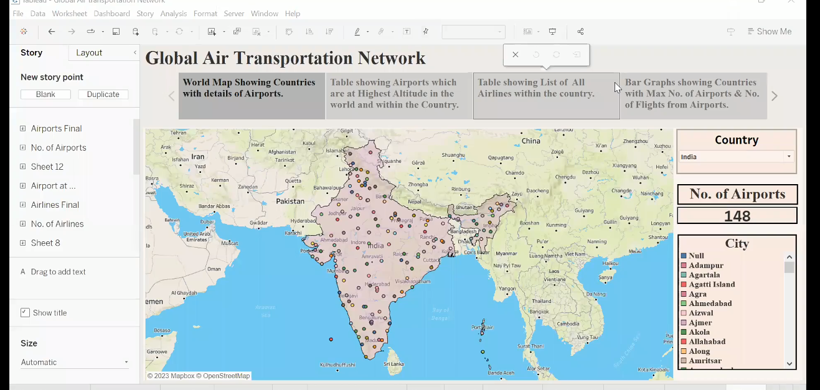

Story link:

Team leader: <https://public.tableau.com/views/kanmaniproject/Story1?:language=en-US&publish=yes&:display_count=n&:origin=viz_share_link>

Mmeber1: <https://public.tableau.com/views/story_16960579565830/Story1?:language=en-US&publish=yes&:display_count=n&:origin=viz_share_link>

Mmeber2:<https://public.tableau.com/views/unlockinginsightsintotheglobalairtranspotationnetworkwithtableau/Story1?:language=en-US&publish=yes&:display_count=n&:origin=viz_share_link>

|  |  |  |  |
| --- | --- | --- | --- |
|  |  |  |  |

Member3:<https://public.tableau.com/app/profile/mani.priya/viz/AIRLINES_16963024665660/Story1?publish=yes>

|  |  |  |
| --- | --- | --- |
| |  | | --- | | https://mail.google.com/mail/u/2/images/cleardot.gif | |  |

|  |  |  |
| --- | --- | --- |
| |  | | --- | | https://mail.google.com/mail/u/2/images/cleardot.gif | |  |

***Milestone 7:*** ***Performance Testing***

***Activity 1:*** ***Amount of Data Rendered to tableau***

The amount of data that is rendered to a Tableau depends on the size of the dataset

***Activity 2: Utilization of Filters***



***4. TRAILHEAD PROFILE PUBLIC URL***

***5. ADVANTAGES AND DISADVANTAGES***

***Advantages:***

1. To understand the importance of transport, its special characteristics must be taken into account.
2. This overlooks a number of advantages that are very attractive and perfectly adapted to the specific needs of each company.
3. Undoubtedly, one of the most advantageous features offered by air transport is its speedy delivery times.
4. There is no faster transport service then air transport. In addition, the frequency of flights makes delivery times very frequent and fast.
5. Air transport is the only means of transportation that does not support physical limits.
6. It is one of the means of transportation that offers practically no interruption in its services, which is very attractive for companies.

**Disadvantage**

1. Although the advantages of air transport are very attractive and define a totally unbeatable type of service, it is also possible to define a series of disadvantages that should be analyzed to determine whether air transport is appropriate or whether it is preferable to consider other types of transport, such as sea transport.
2. There is no doubt that air transport is the least economical means of transportation compared to other types of transport.
3. The cost of infrastructure, fuel… makes air transport economically superior to other alternatives.
4. It is important to know how to analyze and calculate the economic and logistical performance to know if it is the ideal option to be used.
5. Storage capacity is lower than land and sea transport. This is a clear disadvantage, air transport ideal for medium or low loads, but is not so attractive for large volumes of goods.
6. Air transport, due to its specific characteristics, cannot carry certain products or goods.

***6. APPLICATION***

It is used for various purposes, the delivery of time-sensitive goods, and emergency response and rescue missions. The air transportation network is a complex network which has the properties of small-world networks and scale-free networks. The degree distribution of the nodes displays a heavy-tailed distribution. The hubs of the network have large connectivities and long distance connectivities at the same time.

1. ***CONCLUSIONS***

We have shown that organizing the data to display the traffic flow and cancellations at a hub provides an enhanced understanding of the time-dependent data. The visualizations provide an understanding and clarity of time-department data and can assist with developing effective recovery decisions to manage capacity constrains and connectivity during a severe weather event. Visualizations are used to identify hidden patterns or anomalies and aloe the ability to discover solutions.

1. ***FUTURES***

Emerging technologies are reshaping with robotics, artificial intelligence, the internet of things, unmanned aircraft systems and the push for hybrid and electric airplanes just to name a few. Alternative fuels can significantly change the current scenario of aviation in support of the environmental protection.

The industry has a number of domestic and international airlines, as well as a large network of airports. The future of the aviation industry in India is likely to see continued growth and expansion, driven by factors such as a growing middle class, increased tourism, and government policies supporting the industry.

Demo link: https://drive.google.com/file/d/19XR4EjQ86ZRW5_GgaeGlPwyQlUWb6ue9/view?usp=share_link